**HEAD COMMAND:**

The head command, as the name implies, print the top N number of data of the given input.

**Head command with four tags**

-n 🡪number of lines

-c🡪Bytes

-q🡪quiet

-v🡪verbose

**By default :**

$ head file.txt

$ head file.txt file2txt file3.txt

. By default, it prints the first 10 lines of the specified files. If more than one file name is provided then data from each file is preceded by its file name.

**-n🡪number of lines**

$head -n 5 file.txt ---🡪It prints top 5 row in the file.

$head -n -5 file.txt ---🡪It prints all rows except last 5 row in the file.

$head -n 0 file.txt ---🡪It prints nothing. Because we gave 0 lines. Hence it shows nothing.

$head -n -0 file.txt ---🡪It prints all whatever the file consist of txt.(inverse of -previous command)

**-c🡪bytes**

$head -c 5 file.txt ---🡪It prints top 5 bytes of character in the file.

$head -c -5 file.txt ---🡪It prints all rows except last 5 character in the file.

**Other combinations:**

$ls /etc | head -n 15 🡪 what the ls prints from that it will prints top 15 lines.

$ls | head -c 5🡪what the ls prints from that it will print initial 5 character .

$ls | head -c -5 🡪 what the ls prints from that it will prints all except last 5 character.

$head file.txt | sort 🡪 whatever the file.txt consist . It will print in sorted list.

$head file.txt | sort -r--🡪 whatever the file.txt consist . It will print in sort in reverse order.

$head –version -🡪It displays the version of head command.

$head -n 10 file.txt | tail -5-🡪It prints line from 6 to 10 .

**-q🡪quiet(to open more than one file it is used)**

head -q -n 5f1.txt f2.txt 🡪 It prints top 5 row of the two file.

head -q -n -5 f1.txt f2.txt 🡪 It prints all rows except last 5 row of the two file.

head -q -c 5 f1.txt f2.txt 🡪 It prints top 5 bytes of character of the two file.

head -q -c -5 f1.txt f2.txt 🡪 It prints all rows except last 5 character of the two file.

**-v🡪verbose**

head -v file.txt 🡪It prints the file content along with the file name.

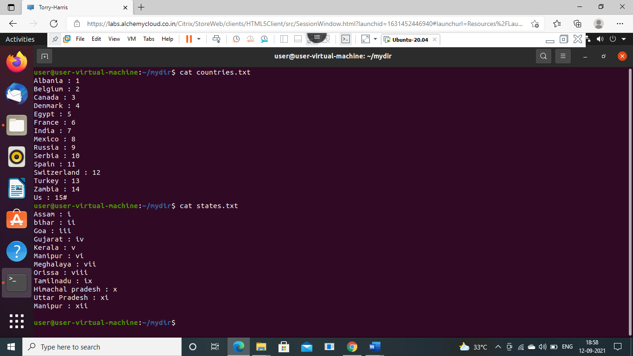

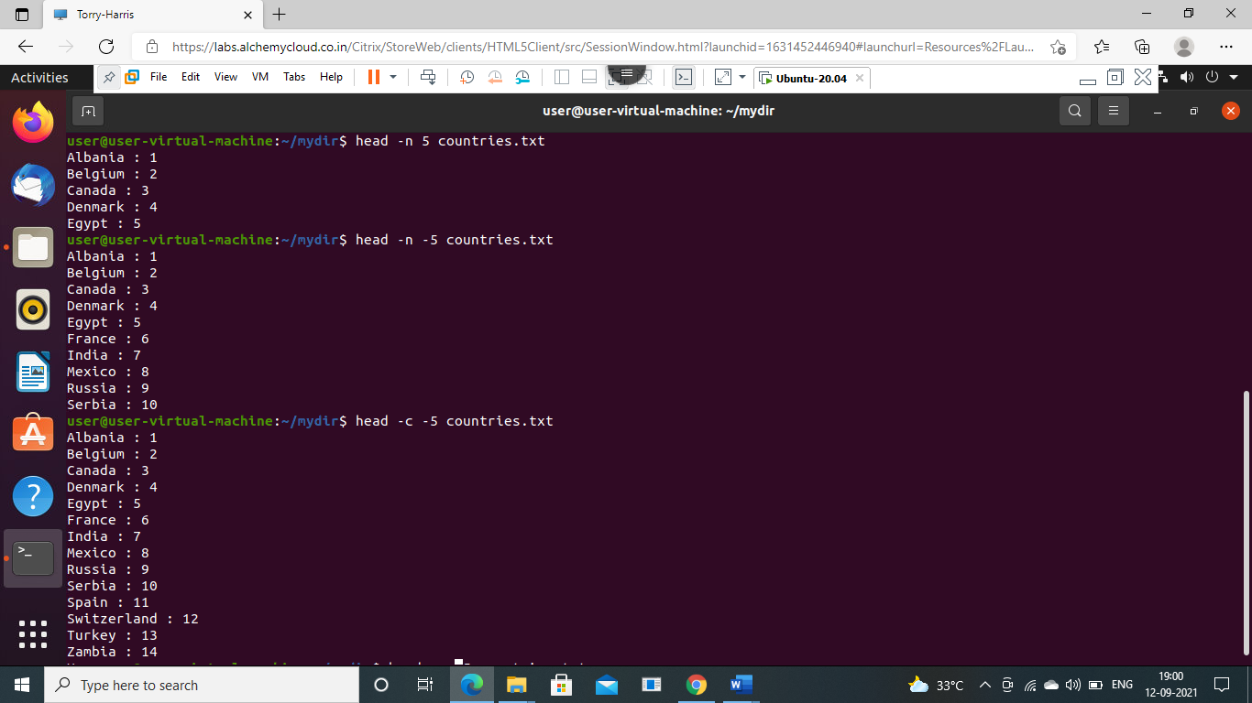

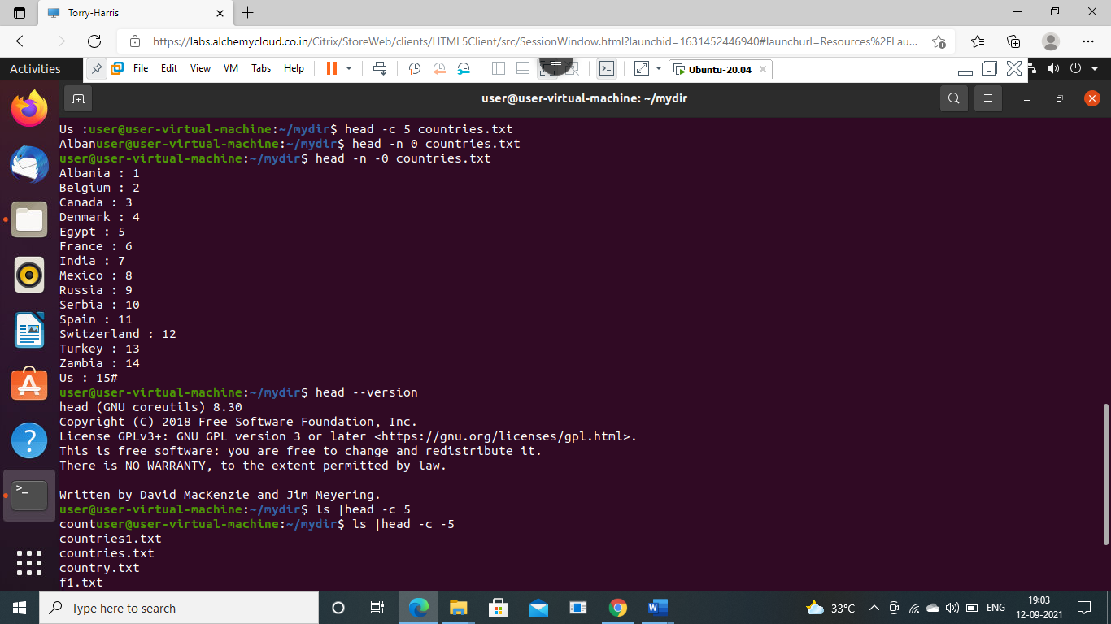

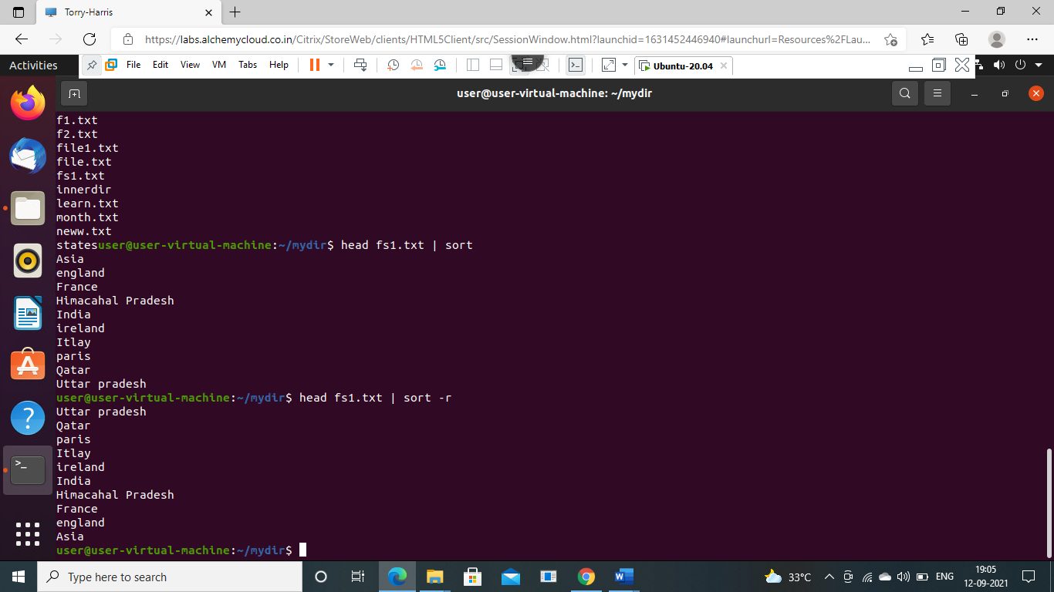

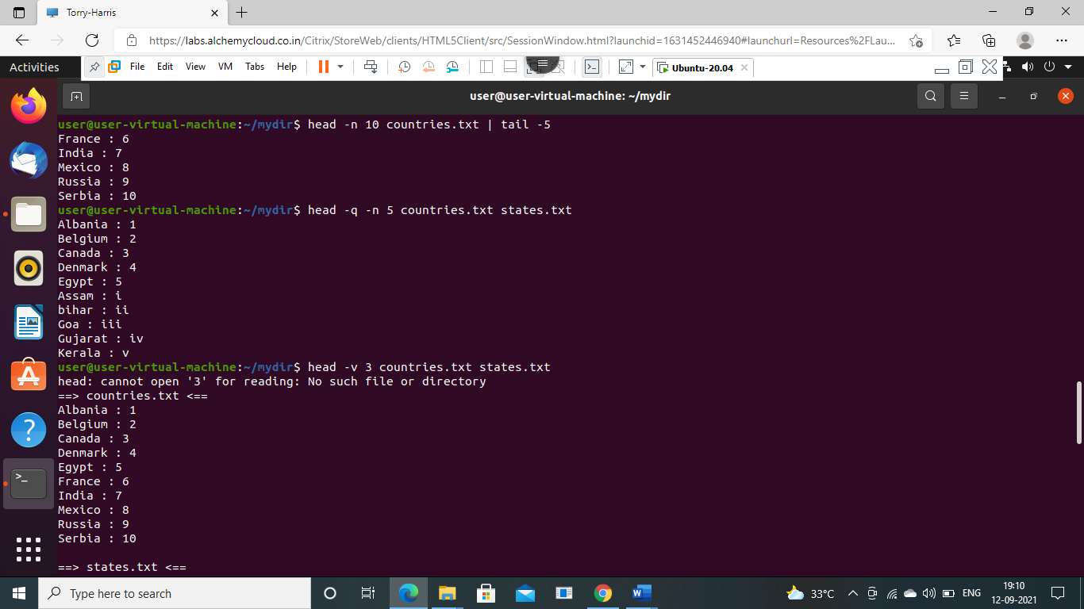

**TAIL COMMAND:**

It is the complementary of [head](https://www.geeksforgeeks.org/head-command-linux-examples/) command.The tail command, as the name implies, print the last N number of data of the given input. By default it prints the last 10 lines of the specified files. If more than one file name is provided then data from each file is precedes by its file name.

**Tail command with four tags**

-n 🡪number of lines

-c🡪Bytes

-q🡪quiet

-v🡪verbose

**By default :**

$ tail file.txt

$ tail file.txt file2txt file3.txt

. By default, it prints the last 10 lines of the specified files. If more than one file name is provided then data from each file is preceded by its file name.

**-n🡪number of lines**

$tail -n 5 file.txt ---🡪It prints last 5 row in the file.

$tail -n -5 file.txt ---🡪It prints all rows except top 5 row in the file.

$tail -n 0 file.txt ---🡪It prints nothing. Because we gave 0 lines. Hence it shows nothing.

$tail -n -0 file.txt ---🡪It prints all whatever the file consist of txt.(inverse of -previous command)

**-c🡪bytes**

$tail -c 5 file.txt ---🡪It prints last 5 bytes of character in the file.

$tail -c -5 file.txt ---🡪It prints all rows except top 5 character in the file.

**Other combinations:**

$ls /etc | $tail -n 15 🡪 what the ls prints from that it will prints last 15 lines.

$ls | $tail -c 5🡪what the ls prints from that it will print last 5 character .

$ls | $tail -c -5 🡪 what the ls prints from that it will prints all except top 5 character.

$tail file.txt | sort 🡪 whatever the file.txt consist . It will print in sorted list.

$tail file.txt | sort -r--🡪 whatever the file.txt consist . It will print in sort in reverse order.

$tail –version -🡪It displays the version of tail command.

$head -n 10 file.txt | tail -5-🡪It prints line from 6 to 10 .

**-q🡪quiet(to open more than one file it is used)**

$tail -q -n 5f1.txt f2.txt 🡪 It prints last 5 row of the two file.

$tail -q -n -5 f1.txt f2.txt 🡪 It prints all rows except initial 5 row of the two file.

$tail -q -c 5 f1.txt f2.txt 🡪 It prints last 5 bytes of character of the two file.

$tail -q -c -5 f1.txt f2.txt 🡪 It prints all rows except initial 5 character of the two file.

**-v🡪verbose**

$tail -v file.txt 🡪It prints the file content along with the file name.



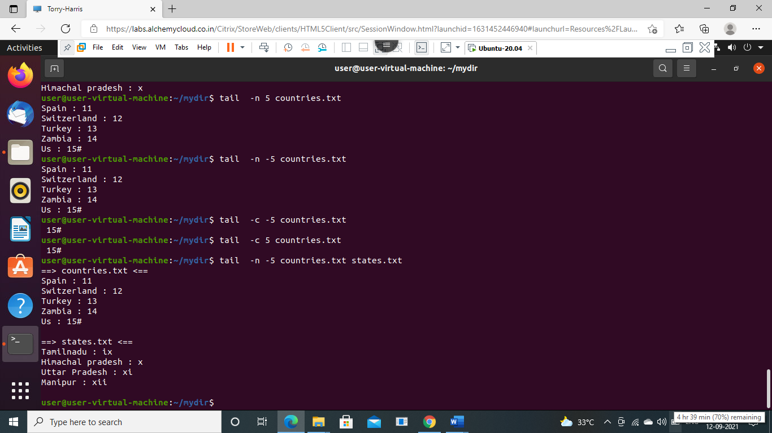

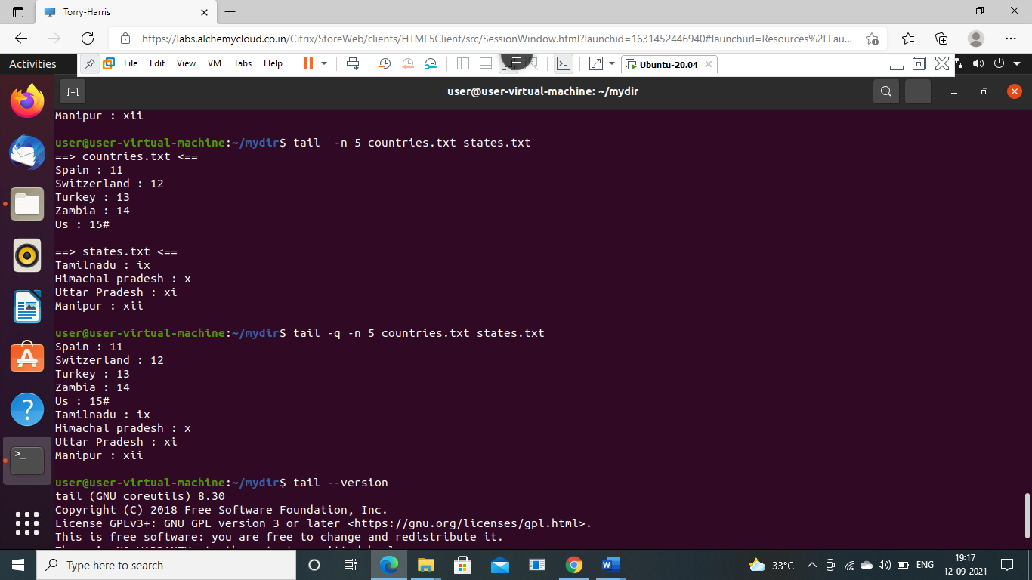

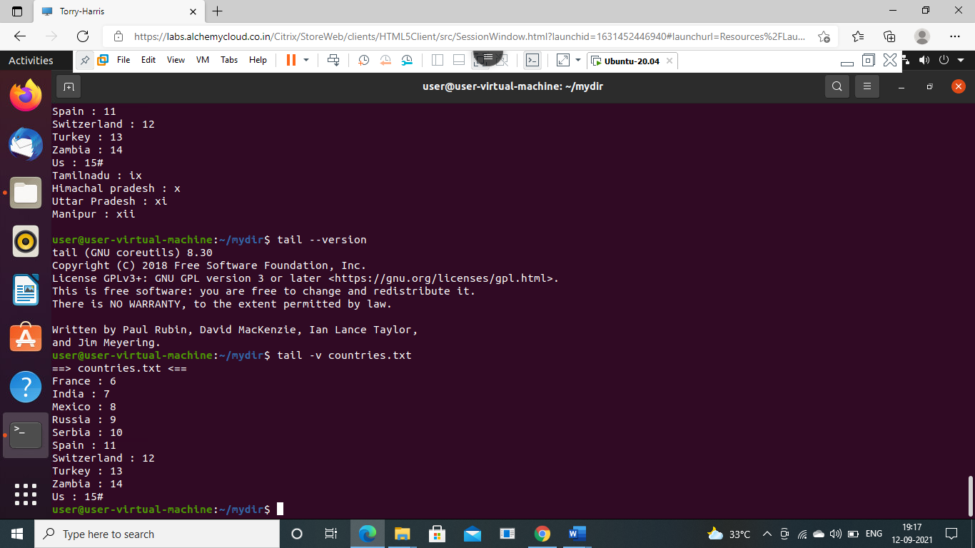

**LESS COMMAND**

**1. View a text file with less**

As showed in the syntax, you can use the less command to view a file in the following fashion:

less [option]<filename>

**2. Exit from less**

If you are not used to of less command, you might struggle to find how to exit

less. Trust me it’s not at all complicated. Simply press ‘q’ at any given point to

exit from less.

**3. Moving around in less**

The output of less is divided into sort of pages. You’ll see only the text that fills

up to your terminal screen.

Up arrow – Move one line up

Down arrow – Move one line down

Space or PgDn – Move one page down

b or PgUp – Move one page up

g – Move to the beginning of the file

G – Move to the end of the file

ng – Move to the nth line

**4. Display line numbers with less**

If you want to see the line numbers in the less command output, you can use the

option N in the following manner: less -N <filename>

**5. Finding text in less**

If you have a large text file, it’s better to search for a specific piece of text rather

than reading it line by line in order to find it manually.

To find a word or phrase or even a regex pattern, press / and type whatever you

want to find. /pattern

**6.View multiple files with less command**

To open multiple files with less, simply input the file names one by one:

less <filename1> <filename2> <filename3>

:n to move next file

:p to move to previous file

**7. less -X file name**

save the file name on screen when file exits

**8.less -S file name**

long line can be seen by side wrapping.

**9.less--version to know the version of less**

**10. less -m file name**

show more detailed prompt including file position.

-N option:

This option shows the file with line number.

Example:

less -N cars.txt

It gives the output as follows

